Subject Line: I’d (We’d) love to help

Email Body:

Hello, __________.

I learned about your organization via _________________, and would like to support your valuable work in our community. I believe I can help (your staff/those you serve) alleviate and better cope with stress via free, 10-minute Reiki sessions.

Programs such as this are very successful in Chicago, where the Reiki Brigade has offered more than 6,000 Reiki sessions to members of the Police Dept., Fire Dept., domestic violence survivors, homeless veterans, incarcerated youth, violence interrupters, youth wards of the state, etc. (see attached photos).

I would like to initiate a similar program here in (your town), and would like to include (name of organization).

Surely you have questions:

1. What is Reiki?
This three-minute video explains Reiki to people about to receive demos at Reiki Brigade outreach events.

2. What Can Reiki Do for You?
This six-minute video shows priceless feedback from veterans and medical students who have just received their first 10-minute demo. Everyone’s experience is different, and these are some of the more enthusiastic responses from outreach events just to show what’s possible.

I’d love to talk to you about the logistics of offering this service to (your team/those you serve).

I look forward to hearing from you,
Your Name
Contact Info

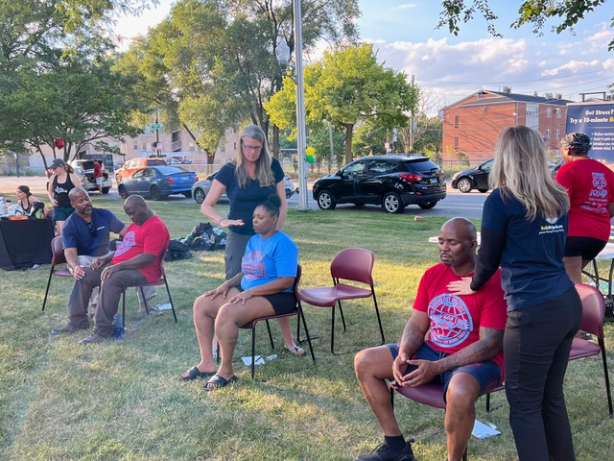

Reiki demos at Boxing Out Negativity’s Street Love bike ride on Chicago’s south side.

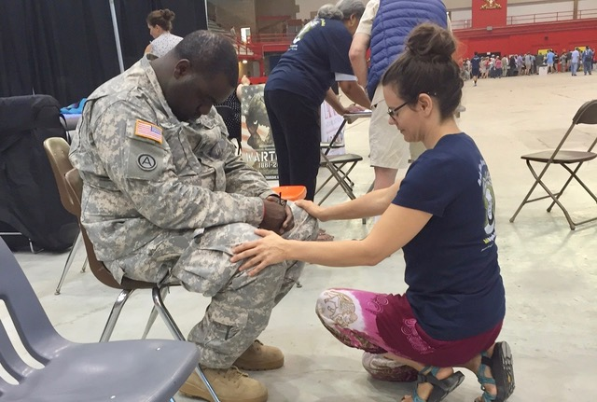

The Reiki Brigade has been working with veterans in partnership
with the Jesse Brown VA since 2011.

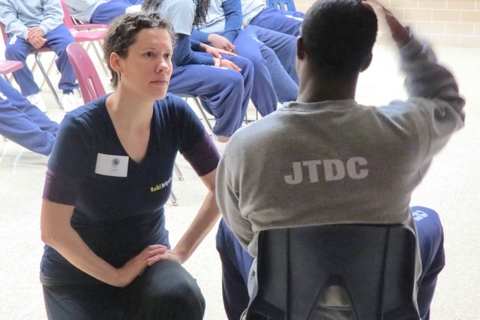

Kids at the Cook County Juvenile Temporary Detention Center loved their Reiki demos.
They reported being more relaxed and sleeping better.

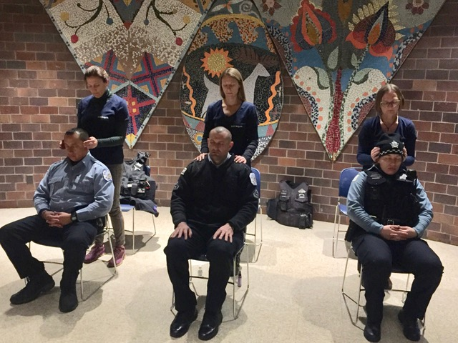

The CPD is recognizing officer stress overload isn’t healthy for anyone.
The Reiki Brigade supports their wellness initiatives.

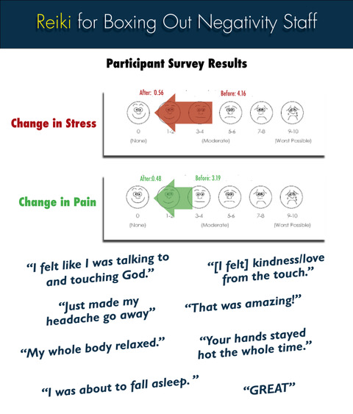

Feedback from Before/After surveys at Boxing Out Negativity.

